**ATWATER KENT RADIOS FOR SALE**

**I have two Atwater Kent radios that were left to me by my deceased brother. I am not a collector myself and would like to find a good home for each of these vintage receivers.**

**Atwater Kent Model 70 Console - from the 1930s with Serial Number E603445 and Chassis Number 6382022. Not sure if it’s a “Highboy” or “Lowboy” but I did restore the cabinet and had the radio itself restored. It seems to run perfectly and does not appear to need any further  
restoration. For this one I am asking $200 or best offer.**

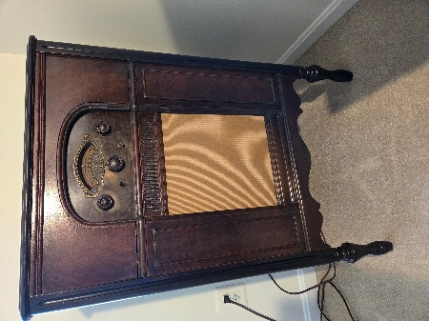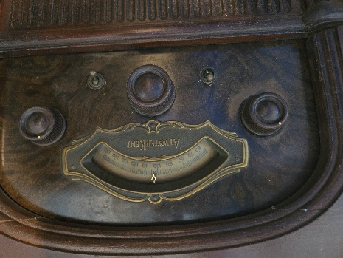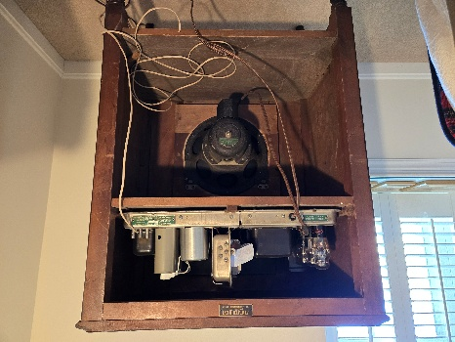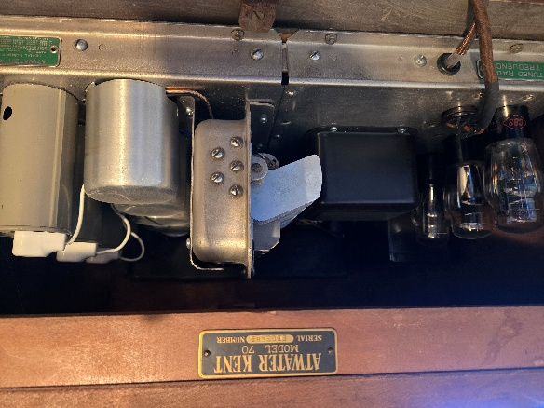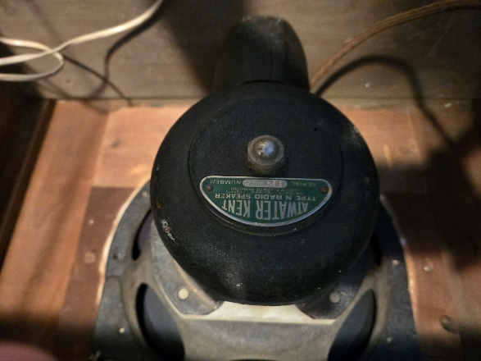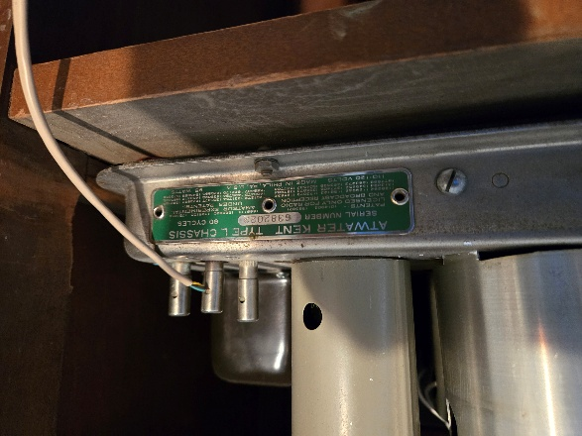

**Atwater Kent Model 206 - This one is a model 206 with a serial number of 1591325 which I believe indicates it is from 1934. This one is a Cathedral-shape and is in perfect physical condition — almost like new. It also seems to run perfectly and requires little or no restoration at all. For this one I am asking $600 or best offer.**

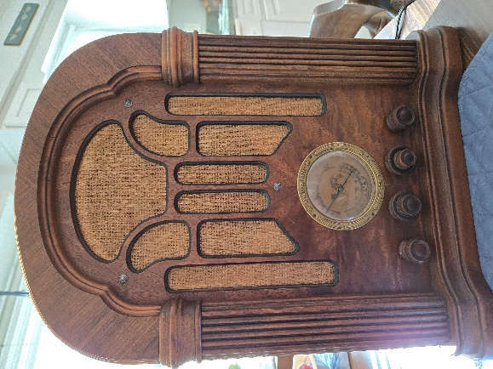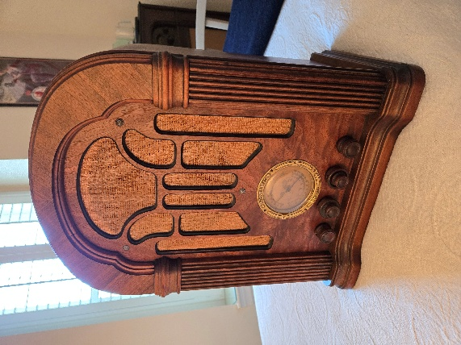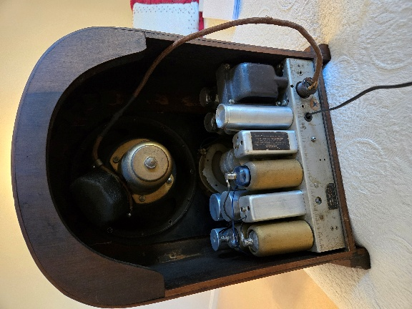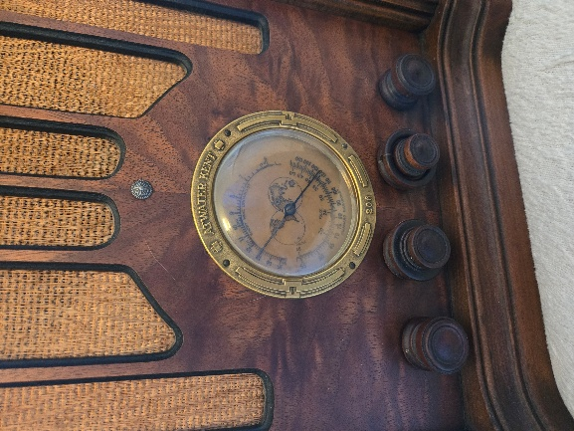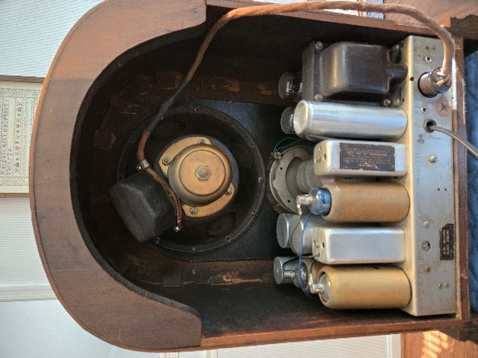

**Here are web links for general descriptions of both radio models:**

[**70 Console Radio Atwater Kent Mfg. Co.; Philadelphia, USA, build |Radiomuseum.org**](https://www.radiomuseum.org/r/atwater_70_console.html)

[**206 Radio Atwater Kent Mfg. Co.; Philadelphia, USA, build |Radiomuseum.org**](https://www.radiomuseum.org/r/atwater_206.html)

**If interested, please contact Steve Boyce on 703-207-9048 or** [**sboycemg@aol.com**](mailto:sboycemg@aol.com)**. Both units are available for inspection and purchase (cash only please) in Vienna, VA.**