GENERAL TELEVISION MODEL 19A5 Possibly, no serial number

Model 526 is similar except that the speaker grill has white plastic louvers. The Collector's Guide to Antique Radios, Third Edition <c>1995 lists Model 19A5 as having plastic louvers but there is no picture. Rider volume 15 shows schematic for models 1A5, 3A5, 5A5, and 19A5 which appear identical to this radio. 1946 model.

7/95 - Cabinet in fair condition. Electrical unknown.
9/95 - Needs speaker, filter capacitor.
11/95 - Replaced speaker, filter capacitor, repaired veneer. Fully functional.
8/26 – Plugged in – NO POWER

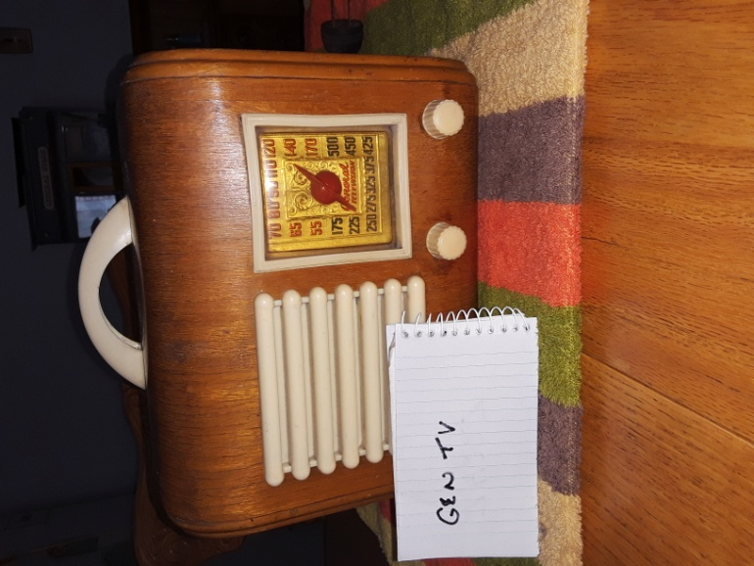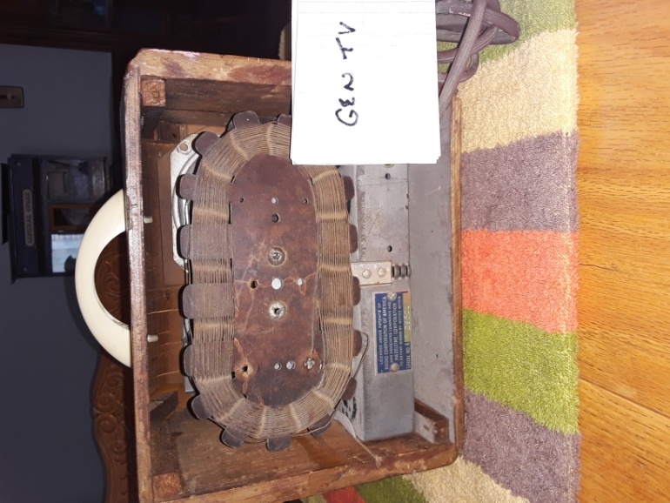

Contact: Bob Landis, WA3SWA wa3swa@gmail.com

Location: Baltimore County – Overlea, Pickup Only

Price: $50 NEGOTIABLE, Cash only

