GRUNDIG MODEL 1070USA “MAJESTIC” SERIAL #103242515

9/95 - Adjusted FM tuning, painted gold trim on cabinet. Fully functional.
8/26 – Receives AM & FM, no hum, pushbuttons are scratchy, plastic broken on one button.

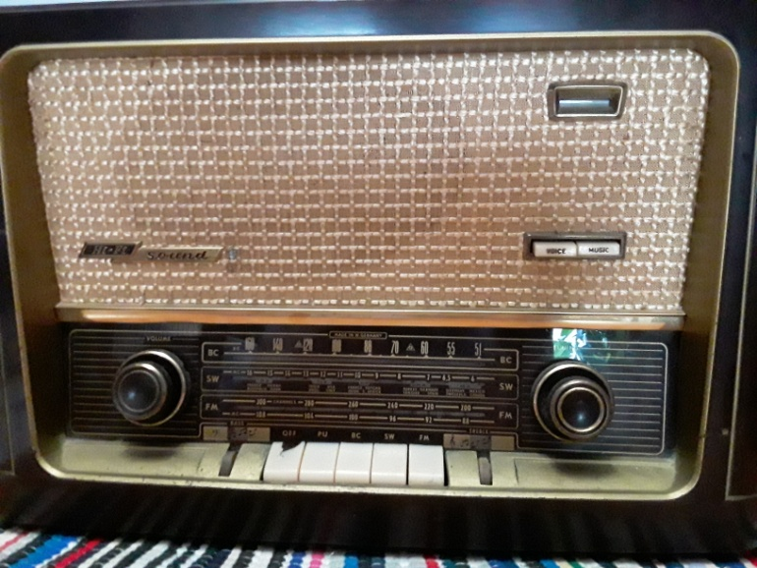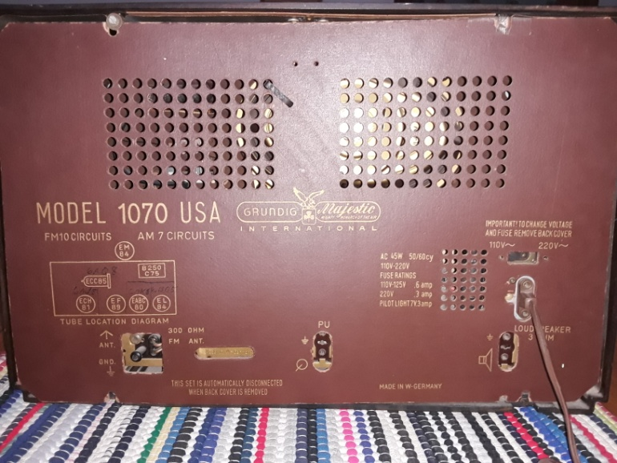

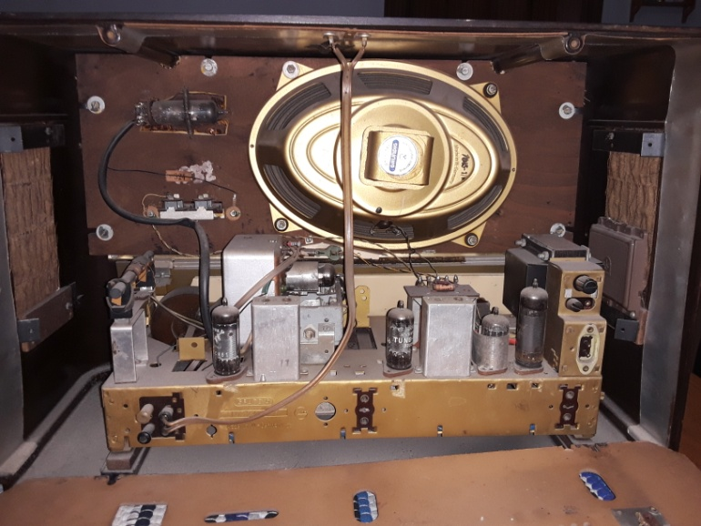

Contact: Bob Landis, WA3SWA wa3swa@gmail.com

Location: Baltimore County – Overlea, Pickup Only

Price: $150 NEGOTIABLE, Cash only

