PHILCO MODEL 38-93B (LATE VERSION) SERIAL NUMBER H21212

Tombstone, 1938, Two-tone wood, rounded shoulders, round dial, grill cut-outs, 2 knobs, BC,AC.

11/94 - Cleaned cabinet and painted chassis.
12/94 - Replaced filter capacitors, power cord, dial cord. Need grill cloth. Fully functional.
2/95 - Replaced grill cloth.
8/26 – Powers on, hum, static, no stations received.

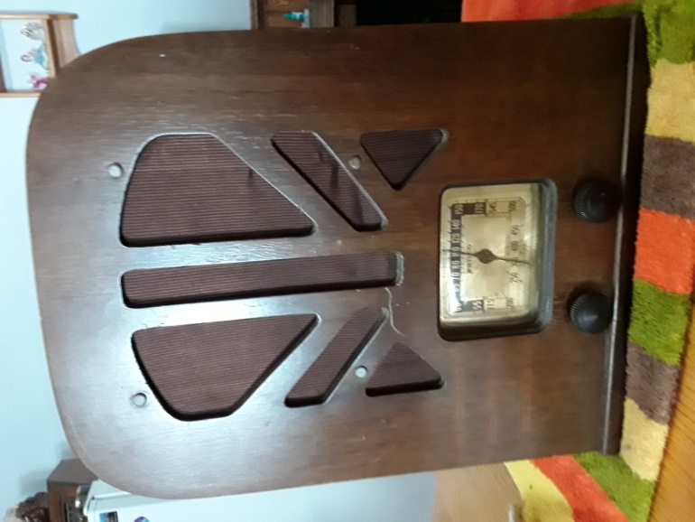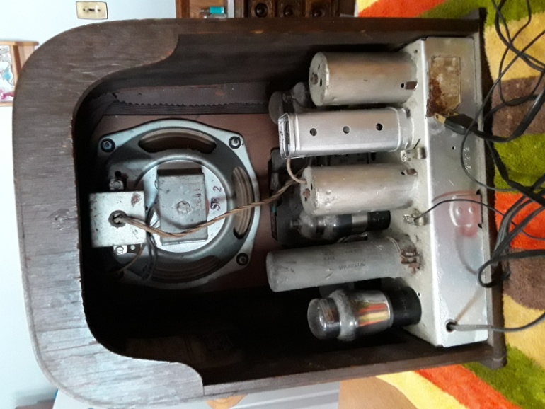

Contact: Bob Landis, WA3SWA wa3swa@gmail.com

Location: Baltimore County – Overlea, Pickup Only

Price: $50 NEGOTIABLE, Cash only

