RCA RADIOLA and VICTROLA ITEMS FOR SALE
1. RCA Radiola 28 Super-Heterodyne Model AR 920 w/ loop antenna and loud speaker # UZ1325- no tubes and non-operational but has intact schematic for tubes under lid. Contact Frank @ boxwood136@gmail.com or 410-848-5263. Westminster, MD $300 or best offer.
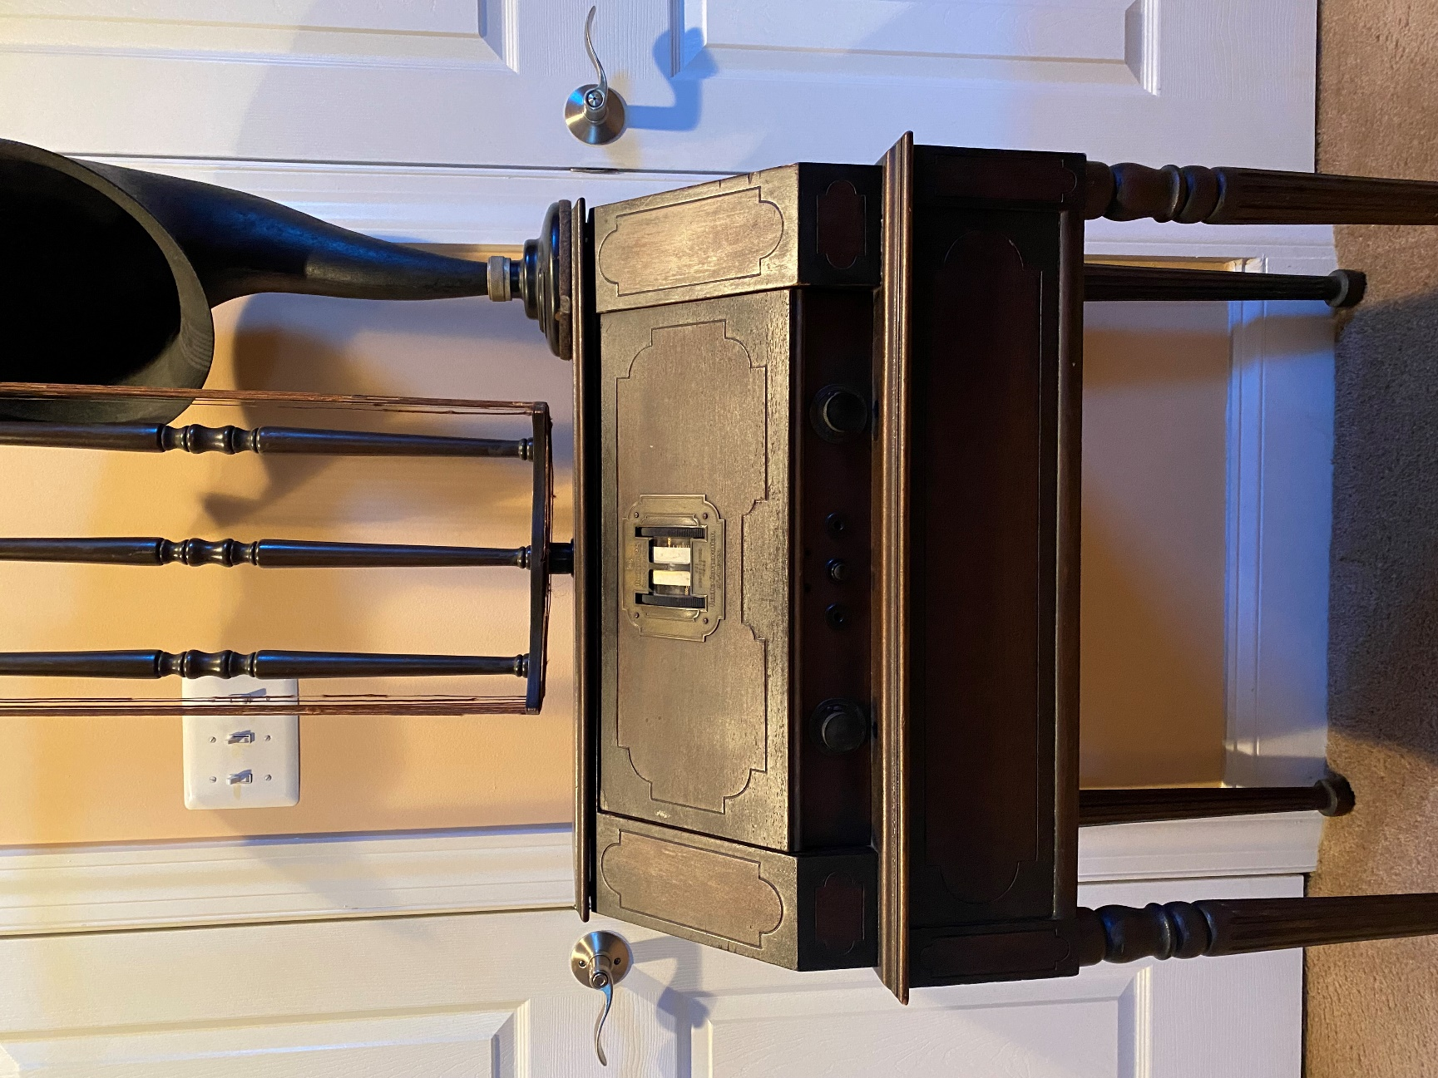
2. Free to whoever buys the RCA Radiola 28- Victrola and antique radio ephemera, pamphlets, and books: Nipper tray; Nipper salt and pepper shakers; framed Victrola print ad; framed Zon-O-Phone print ad; A Guide for the Radio Builder by F.F. Webb (1920s); 20 Years of Corn: Don McNeill’s Breakfast Club (1952); Philco Radio Atlas of the World (1935); Lafayette Radios catalog (1935); Frank C. Jones Radio Handbook (1937); Supplement to Frank C. Jones Radio Handbook (1937); RCA Victor Radio Amusement and Educational Map of the World (1938); Music America Loves catalogue (RCA Victor), 1950; I.C.S. Radio Operator’s Handbook (1923); This Fascinating Radio Business by Robert J. Landry (1946); The Television Annual for 1953; Practical Wireless Telegraphy by Elmer E. Bucher (1921); The Principles of Radio by Keith Henney and Glen A. Richardson (1952); Radios: The Golden Age by Philip Collins (1987) (beautifully enhanced by color photos of many models). Contact Frank @ boxwood136@gmail.com or 410-848-5263. Westminster, MD.
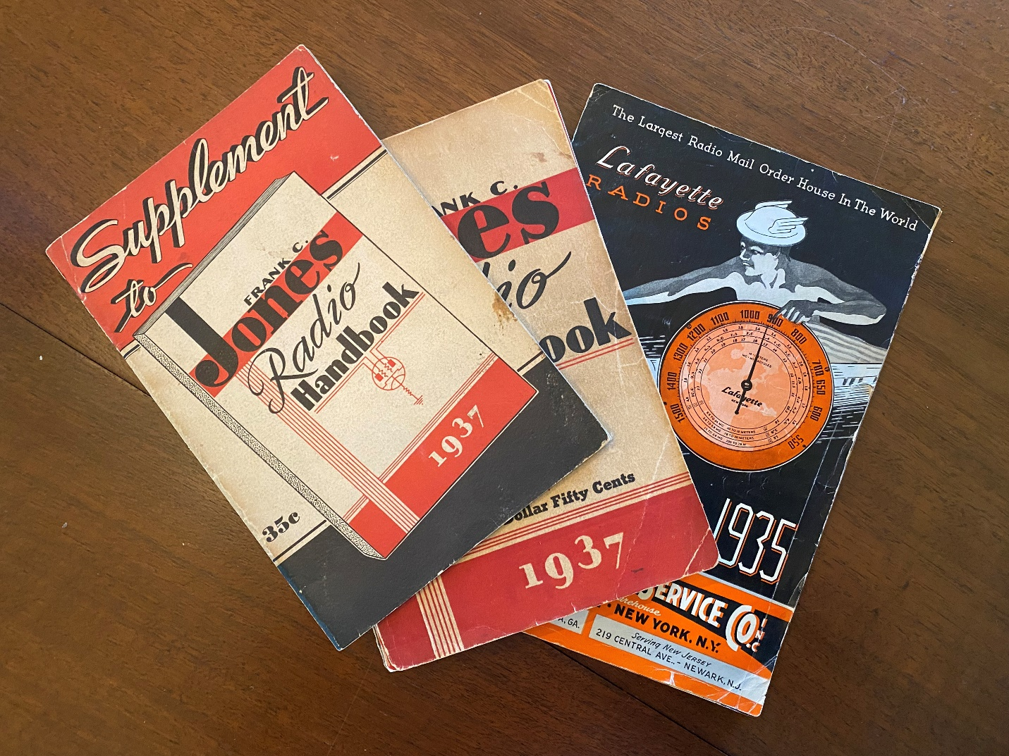
3. RCA Radiola cabinet w/o parts. Contact Frank @ boxwood136@gmail.com or 410-848-5263. Westminster, MD $25.

4. RCA Victrola VV 210, #90066 (1922). Contact Frank @ boxwood136@gmail.com or 410-848-5263. Westminster, MD $100.
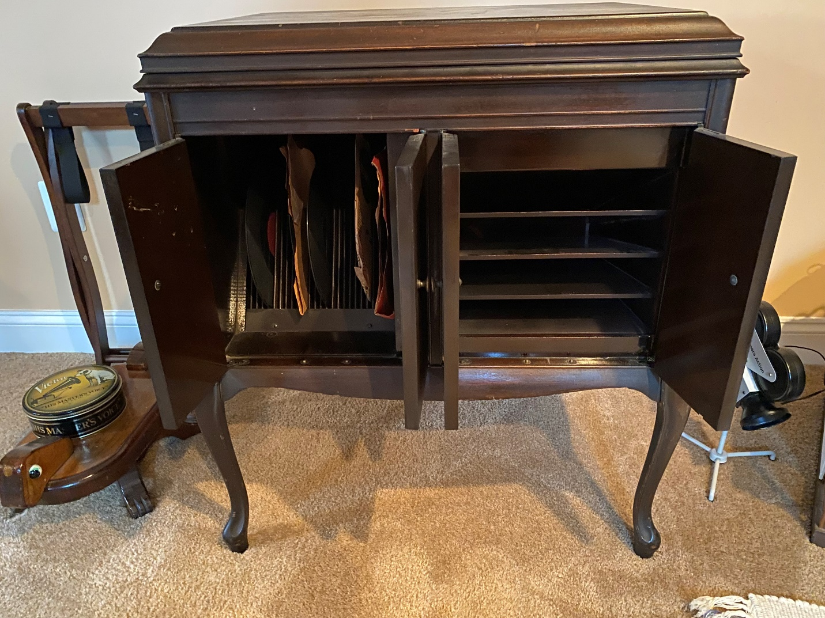

5. RCA Victrola record cabinet. Contact Frank @ boxwood136@gmail.com or 410-848-5263. Westminster, MD $30.
