STROMBERG CARLSON MODEL 500-H (BLUE) SERIAL NO. 346336

The blue is factory painted with no crazing. Blue color is VERY RARE!

Table, 1940, bakelite, right front dial, left cloth grill w/horizontal bars, decorative case lines, 3 knobs, BC, AC/DC.

8/94 - Replaced tubes and capacitors. Fully functional.
8/26 – Receives OK, volume control scratchy, has hum.

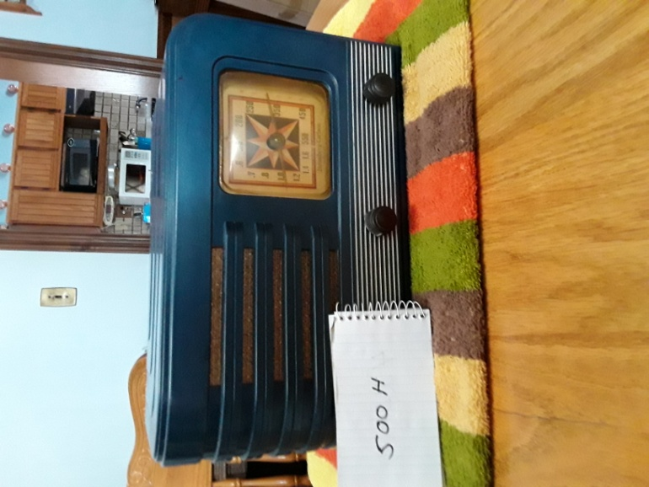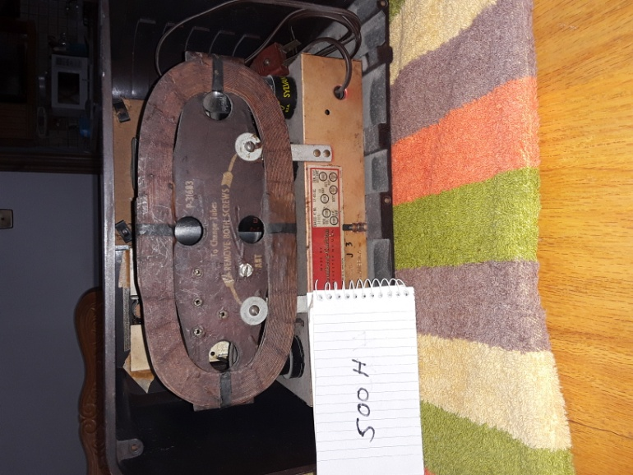

Contact: Bob Landis, WA3SWA wa3swa@gmail.com

Location: Baltimore County – Overlea, Pickup Only

Price: $100 NEGOTIABLE, Cash only

