ZENITH 7H922, Chassis 7F02

Bakelite, AM & FM

8/26 – UNTESTED, power cord cut off back.

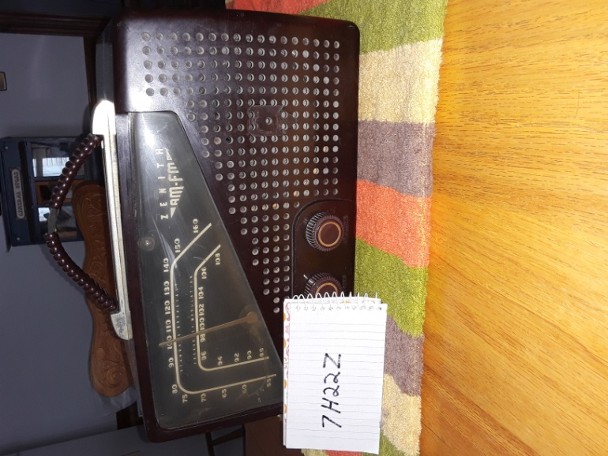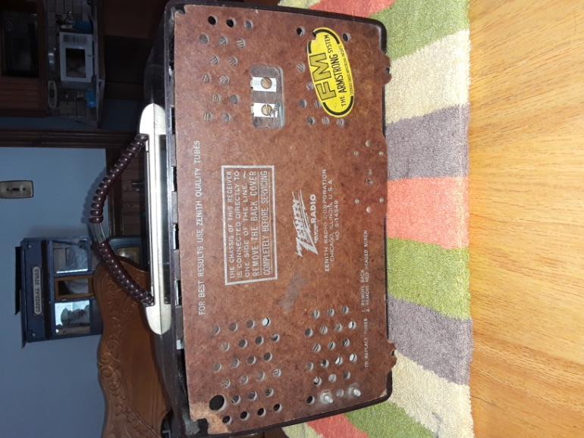

Contact: Bob Landis, WA3SWA wa3swa@gmail.com

Location: Baltimore County – Overlea, Pickup Only

Price: $25 NEGOTIABLE, Cash only

